**Name : Vaidik Prajapati**

**Assignment module 1 : Understanding of Hardware and its Components.**

* **Section 1 : Multiple Choice**

1. **Which of the following is NOT a component of the CPU?**

**Ans : RAM**

**Note :** Because Ram is a type of memory.

1. **What is the function of RAM in a computer?**

**Ans :** RAM provides the temporary storage to the running applications and handling active data.

1. **Which of the following is a primary storage device?**

**Ans :** RAM

**Note : All options ( HDD, SSD and SD Card ) are secondary storage devices.**

1. **What is the purpose of a GPU?**

**Ans :** GPU helps to handle graphics, effects and video. And accelerate the graphics rendering.

* **Section 2 : True or False**

1. **The motherboard is the main circuit board of a computer where other components are attached.**

**Ans :** True

1. **A UPS (Uninterruptible Power Supply) is a hardware device that provides emergency power to load when the input power source fails.**

**Ans :** True

1. **An expansion card is a circuit board that enhances the functionality of a component.**

**Ans : True**

* **Section 3 : short answers**

1. **Explain the difference between HDD and SSD.**

**Ans :** HDD :

1. Random access time is 5-10ms
2. Read latency time is high
3. Data transfer speed is 50 MB/s to 100 MB/s
4. HDD have moving parts and subject to sudden failure.
5. Size is large and heavy
6. Power consumption is 6-12 watts.

SSD :

1. Random access time is 0.1ms
2. Read latency is very low
3. Data transfer speed is 100 MB/s to 500 MB/s
4. SSD have no moving parts to fail
5. Size is small and light weight
6. Power consumption is 2 watts
7. **Describe the function of BIOS in a computer system.**

**Ans** : Basic input output system set up the computer and boot the operating system. The BIOS’s primary function is to handle the system setup process including driver loading and OS booting.

1. **List and briefly explain three input devices commonly used with computers.**

**Ans :**  **Input devices:**

1. Keyboard
2. Mouse
3. Joystick
4. keyboards : The keyboard is main input device and used to write any text or any command task.
5. Mouse : it is also called a pointing device mouse used to open and close any

application with help of cursor.

1. joystick : it is input device with a stick attached and is used to control the direction of the device. it is commonly used in gaming.

* **Section 4 : Practical Application**

1. **Identify and label the following components on a diagram of a Motherboard.**

* **CPU**
* **RAM SLOT**
* **SATA CONNECTORS**
* **PCI-E SLOT**

**PCI-E SLOTS**

**CPU**

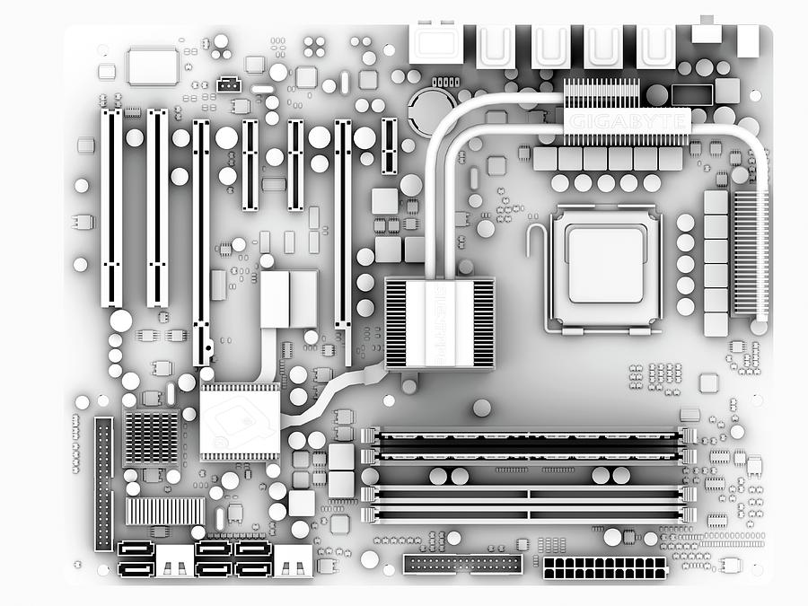

**RAM SLOTS**

**SATA CONNECTORS**

1. **Demonstrate how to install a RAM module into a computer.**

**Ans : Step 1 :** Locate the RAM slot on your motherboard.

**Step 2 :** Push down the locking tab(s) at the end of each slot.

**Step 3 :** after that match the ram’s notch with ram slot

**Step 4 :** And at last push down the ram until it makes clicking sound.

* **Section 5 : Essay**

1. **Discuss the importance of proper cooling mechanisms in a computer system. Include examples of cooling methods and their effectiveness.**

* Some of the popular cooling methods and their efficacies are:

1. Fan-less Cooling (30-50% effective) : This approach cools systems without using fans, perhaps through the use of heat pipes or thermal interfaces.
2. Air Cooling: 40-60% effective; uses fans to circulate air through the system and dissipate heat from the components.
3. Liquid Cooling (70-90%): Liquid coolant here absorbs heat from components and transfers it to a radiator for dissipation.
4. Heat Sink Cooling (50-80% effective): It is a passive method which utilizes a heat sink-metal block with fins-designed to dissipate heat from components.
5. PCM Cooling (80-95%): This uses a phase change material that becomes liquid when it absorbs heat; it hence possesses a strong cooling ability.
6. Hybrid Cooling (90-99% Effective): Hybrids two or more cooling techniques, such as air and liquid, for best performance.

* Effective cooling ensures:

- Reliable system operation  
- More component life  
- Low maintenance  
-Thesis Statement  
-Improved overall performances

1. **Explain the concept of bus width and its significance in computer**

**architecture.**

**Ans :**In computer architecture, the concept of bus width is fundamental to understanding how data is

transferred between different components within a computer system. Here’s a detailed explanation of bus

width and its significance:

1. Data Transfer Rate: A wider bus allows more data to be transmitted at once, increasing the data transfer

rate.

1. System Performance: A wider bus improves system performance by reducing clock cycles required for data transfer.
2. Memory Access: Bus width affects memory access speed, with wider buses transferring more data between CPU and memory.
3. CPU Performance: Bus width can limit CPU performance, with narrower buses bottlenecking CPU capabilities.